**Create 3 jobs (Sequential)**

**- Job 1- Will clone the repository**

**- Job 2- Will build the project**

**- Job 3 - Will deploy the war file on server.**

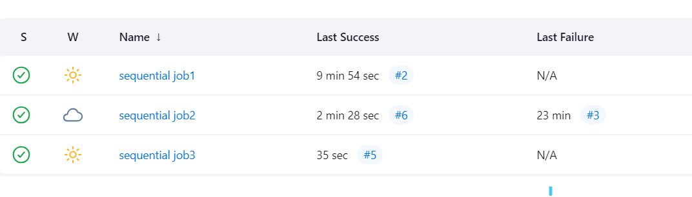

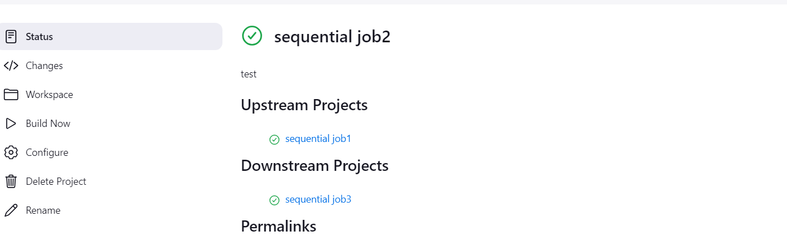

**Job1- clone the repo**

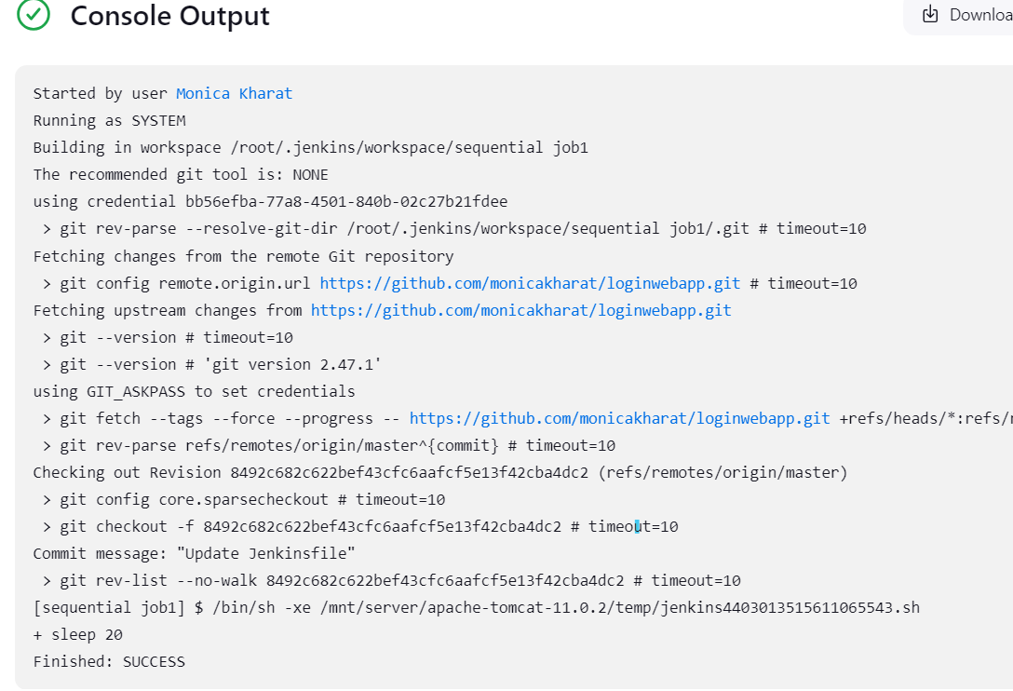

**Job2 -build the project**

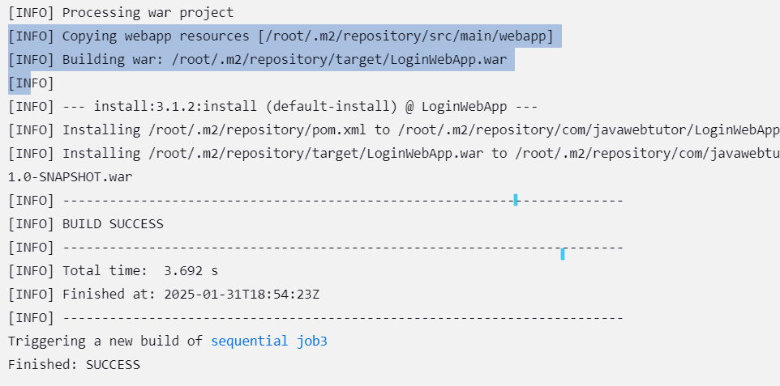

**Job3-deploy war on server**

